Undergraduate Project Report
Student: Yu Ting Chiu
ELECENG: 410/410G
Part 1.
(a) Hand: Compute the Frequency Response. h[n] = {0.2, 0.4, 0.4, 0.2}
Ans(a): H(e^jw) = 0.2+0.4e^(-jw) +0.4e^(-j2w) +0.4e^(-j3w)
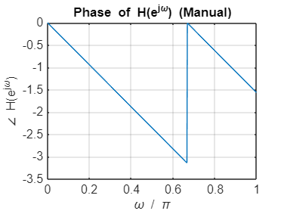
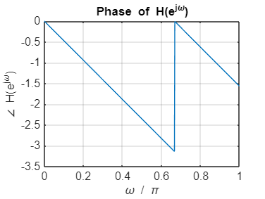
(b) the graph are same as the previous part(manual)
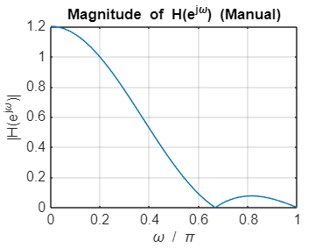
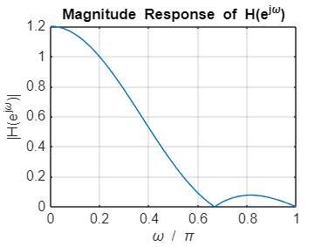
(c)
Cutoff Frequency1: 0.2695*pi (539.06 Hz)
Cutoff Frequency2: 0.2695*pi (1078.12 Hz)
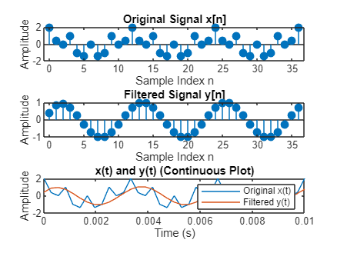
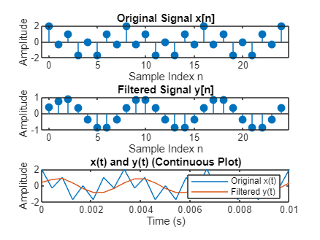
Part 2.
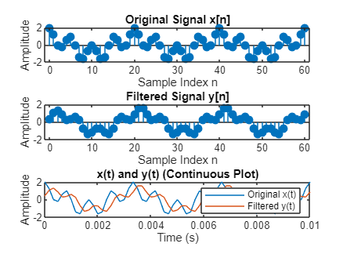
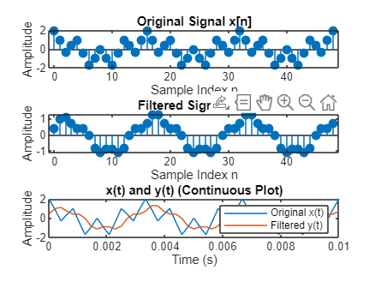
Fig2.
Fig1.
Fig3.
Fig3.
Fig4.

Figure 1. Fs=2400Hz Figure 2. Fs=3600Hz
Figure 3. Fs=4800Hz Figure 4. Fs=6000Hz
In a fixed h[n] [ex. h[n] = {0.2, 0.4, 0.4, 0.2}] the 1200Hz component appears suppressed when fs=2400H. However, since my fs is higher(ex.6000Hz), it appears that not apparently suppressed in 1200Hz is because changing the sampling frequency fs shifts the actual cutoff frequency.

Part 3.
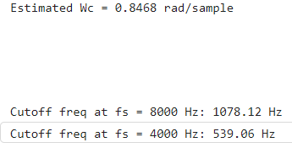
1.
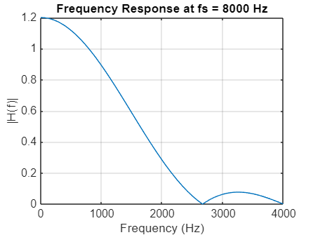

2.
As fs increases, the actual cutoff frequency fc in Hz increases proportionally. As fs decreases, fc in Hz decreases proportionally. It means that Cutoff frequency fc in Hz is directly proportional to the sampling frequency fs, given a fixed normalized cutoff frequency.
Choosing proper Fs can 1. Prevents aliasing 2. Determines the actual cutoff frequency in Hz 3. Balances filtering precision and efficiency

